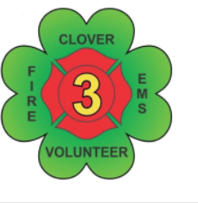
Clover Volunteer Fire Department, Inc.
“Neighbors Helping Neighbors since 1949"
PO Box 199
Clover, Virginia 24534-0199
Phone 434-454-7340
E-Mail cvfd@pure.net Website www.clovervfd.org

PERMISSION FORM FOR MINORS 14-17 YEARS OF AGE

I____________________________ agree to the following conditions of the Clover Volunteer Fire Department Inc. to be a Cadet Member or Junior Member.

Cadet Program 14-15 years old Junior Program 16-17 years old

- Shall maintain a grade average in each class of C and/or suitable to his/her legal guardian.

- Shall remain as a Cadet Member until the age of 16.

- Shall remain as a Junior Member until the age of 18.

- Shall not enter a Hazardous Atmosphere (remain in cold zone) unless you have completed the Fire Fighter 1 course (Junior Member). You may enter limited during controlled training events.

- Shall not be absent from school for any Fire Department related activity unless approved by his/her legal guardian.

- Shall not carry Fire Department pager to school.

- Shall not bring anyone to the station unless a Regular member is present until the age of 18 unless it is a Fire Department related activity.
- Shall not respond to any fire call unless they have permission of the Officer in Charge and respond with a Regular Member in one of our support units.
- It shall be understood that Cadet Members and Junior Members are covered under the Clover Fire Department insurance.

I________________________________ agree to all the above conditions and give permission for my child to be a member of the Clover Volunteer Fire Department Inc.

Sign: ________________________________

Date: ________________________________

