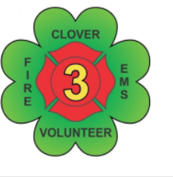
Clover Volunteer Fire Department, Inc.
“Neighbors Helping Neighbors since 1949"
PO Box 199
Clover, Virginia 24534-0199
Phone 434-454-7340 - Fax 434-454-4166
E-Mail cvfd@pure.net Website www.clovervfd.org

We are looking for Cadet/Junior members. Are you 14 or older looking for volunteer options? You will be starting your future locally and helping your neighbors while entering your future career field All you need is parents’ consent to apply. As a Cadet/Jr. member you will be introduced to the Fire and EMS Field. You will be linked to various trainings and classes that will allow you to prepare to become a First Responder. You will have the chance to become CPR certified and Stop the Bleed certified. Options to complete various classes such as Fire Fighter 1 and 2, EMT classes, EVOC, and other special training that will aide in you exceling in your position as a fist responder and prepare you for a potential career in the field. Areas near us are always hiring. Listed is a ballpark of the potential pay rates based on certifications and trainings:

Chesterfield - $ 50,000
Lynchburg - $43,000
Danville - $ 40,000
South Boston - $ 40,000
Halifax Rescue - $ 32,000 EMT / 38,000 ALS

As a Cadet/Jr. member you will get lots of hands-on experience. You will be mentored by seasoned department members and gain skills to prepare you membership once you turn 18. You will attend meetings and trainings. You will be able to contribute to meetings and trainings. Cadet/Junior members will also aide in planning and carrying out fundraising events. Community engagements are always fun and will be assisted by Cadet/Junior members as well. If you are interested in becoming a Cadet/Junior member please contact any member or visit our website for an application.

